Transfer Proposal

Understanding the role of neuromodulation in the olfactory circuit of the fruit-fly

# Abstract

The fruit fly uses its sense of smell to discover useful facts about the world.

Previous experiences of different smells get stored in the fly brain along with information on whether the smell was associated with reward or punishment.

Flies will use their sense of smell to decide whether to approach or retreat from a given odour. The place this information gets stored is the mushroom body an area comprised of thousands of neurons that has been implicated in olfactory memory and decision-making.

Experiments have shown the response of a fly to a given odour is determined by the activity of a small group of so called "output neurons" which receive their input from the mushroom body and are affected by neuromodulators such as dopamine and octopamine, with experimental evidence suggesting that dopamine and octopamine control reward based learning.

David et al. observed that when imaging an output neuron (M4$/beta'$) before and after learning, this neuron exhibited a bi-directional change in firing rate depending on the reinforcement used (reward or punishment) in the experimental protocol. When the odour was paired with appetitive reinforcement the odour response of the output neuron decreased. Conversely, when the odour was paired with an aversive stimulus the odour response increased. The process of encoding odour valence is believed to be dependent on the activity of three types of neurons. Each odour activates a unique subset of Kenyon Cells (KCs) in the mushroom body which are tasked with identifying an odour, dopaminergic neurons (DAs) are believed to signal reward or punishment and mushroom body output neurons (MBONs), depending on their type are believed to bias behaviour towards either approach or retreat. Previously it has been shown that activation of glumatametergic MBONs simultaneous with activation of DA neurons induced appetitive or aversive memory depending on the DAs type (Perisse et al. 2013 add). The evidence appears to suggest that dopamine modulation leads to synaptic depression of the output of the KCs that represent the odour.

As a first step, I created a biologically plausible model of the mushroom body KCs, MBONs and DAs based on their known connectivity, to investigate which plasticity rule is sufficient to explain experimental results. More exactly, is it possible to explain bi-directional change in firing rate by using a learning rule where activity of dopaminergic neurons always leads to depression? We would like to test whether potentiation can be explained by disinhibition from other output neuron or whether a synaptic learning rule that allows synapses to change in both direction is necessary. Furthermore, the study by David et al. suggests there is a feedback loop from MBONs to DAs, which would make valence learning a recurrent circuit. We want to test what the functional implications of a feedback loop for bidirectional valence learning.

# INTRODUCTION

Like all living organisms, the fruit fly uses sensory information to navigate its world. To a first approximation a fruit fly’s behaviour in response to a sensory input can be described as a decision making process of approach or retreat. One such sense the fly uses to decide whether to approach or retreat is the sense of smell, which is a well-studied function, employed to gather information about the environment, find food, mating partners, and detect dangerous conditions signalled by harmful odours. From the stage of larvae, flies are attracted to most odours, but also show innate aversion to specific odours. The behaviour of larvae depends on experience: if an odour is associated with a sweetened reward and another odour offers no reward the flies will show a preference for the rewarded odour in a binary choice test. However, if an odour is associated with a punishment such as high-concentration salt taste, larvae can be conditioned aversively to odours (Niewalda et al., 2008).

Understanding how memories of odours are generated and how they affect behaviour is an area of current research. Researchers are also beginning to understand how innate and learned olfactory behaviours interact with each other.

However, until now there have been few computational models that have converted word models into mechanistic models that explain the growing behavioural data and make predictions and testable hypotheses.

Flies detect odours using olfactory receptor neurons (ORNs) housed in their antennae. The tuning of each OSN is determined by a single odorant receptor gene (Hallem & Carlson, 2006). Axons from the ORN expressing the same receptor always converge to the same site in the antennal lobe, which is a glomerulus. Their activity is picked up by inhibitory and excitatory projection neurons. Excitatory projection neurons (ePNs) deliver information to the calyces in the mushroom body while both inhibitory projection neurons (iPNs) and ePNs send information to the lateral horn which is a structure implicated in innate odour identification.

## Mushroom body

The mushroom bodies are symmetrical structures with each mushroom body being composed of 2,000 KCs with each odour activating a unique subset of these neurons (Honegger, Campbell, & Turner, 2011). The dendrites of the KCs form the cap or calyx of the MB, and their axons project anteriorly to form the stalk or peduncle before those axons terminate in one or more lobes, termed ab, $\alpha’\beta’$ , and $\gamma$ lobes

Subsets of Kenyon Cells have unique roles in memory processing. In a previous study it has been shown by blocking different anatomical subdivisions of KCs, that the surface $\alpha\beta$ neurons are needed during retrieval of aversive and appetitive memory whereas $\alpha\beta$ core neurons, when blocked only affect appetitive memory (Perisse et al., 2013).

Olfactory representations in the mushroom bodies are modulated by anterior paired lateral (APL) and dorsal paired medial (DPM) neurons. The gap-junctional connection between DPM and APL could guarantee that excitation from DPM is balanced by a similar magnitude of inhibition from APL.

The gap junction between the APL and DPM neurons has been shown to play an essential part for the mushroom body during memory formation, constituting a recurrent neural network (Pitman et al., 2011)

## Dopaminergic neurons

Dopaminergic neurons (DANS) are the most prevalent modulatory neurons that innervate the mushroom bodies. There are distinct dopaminergic neurons that provide positive and negative value signals. The two major clusters where most DANs reside are the PPL and the PAM clusters (Figure 1c).

Positive reinforcement are provided by subsets of the approximately 100 DANs in the PAM cluster (Burke et al., 2012), . They predominately innervate nearby zones in the $\beta, \beta’, \gamma$ lobes. Distinct DANs convey the effects of sugar and water reward as opposed to the same neurons representing subjective value. The sugar and water responsive DANs project to unique zones on the MB lobes, thus suggesting that learning-related plasticity is represented in different places along the axon of an individual KC.

Negative reinforcement such as from electric shock or bitter substances appears to be conveyed by DANs housed in the PPL cluster. Each PPL DAN that innervates the mushroom bodies projects presynaptic terminals on the vertical lobes $\alpha$ or $\alpha’$ or heel and surface of the peduncle (David Owald & Scott Waddell – in review)

It is believed that since DANs reaches a subset of KCs axons, they modify KC output synapses onto MBONs in their respective zone. Thus water memories and sugar memories are predicted to have unique KC-MBON connections that represent them.

State-dependence – an additional level of dopaminergic control

## MUSHROOM BODY OUTPUT NEURONS

Outputs from approximately 2,000 Kenyon cells of the mushroom body converge onto a population of only 34 mushroom body output neurons (MBONs), which fall into 21 anatomically distinct cell types (Aso et al., 2014) . The dendrites of MBONs is restricted to few DAN zones. In the neuron where bi-directional change in firing rate has been observed, the axons from sugar rewarding dopaminergic neurons overlap with the dendrites of the MBON.

In a recent study, MBONs were found to be broadly tuned, showing high levels of correlation between different MBON types. In comparison to representation in the KCs, odours in the MBON were found to be much closer to one another. The odour representations in MBON of two groups of opposite valences was found (Hige, Aso, Rubin, & Turner, 2015).

Previous studies have shown that dopamine-drive plasticity occurs during reinforcement learning at the KC-MBON-DA junction. Aversive learning has been shown to depress odour-drive to the vertical lobe MBONs. Reward learning was shown to potentiate the V3 MBON.

Two competing theories could explain the effect of dopamine on the KC-MBON synapse. According to the first, dopamine always depresses the synapse. In this case potentiation would occur through the mechanism of lateral disinhibition from MBONs encoding opposite valences. This hypothesis is supported by anatomy that shows that generally DANs overlap with the dendrites of MBONs that bias towards

In the second scenario, dopamine can exercise bi-directional control over the synapse leading to both potentiation and depression. This level of control would have computational benefits, allowing dopamine to ‘fine-tune’ the synapse until it reaches a target value.

The M4 MBON exhibits bi-directional change in firing rate which makes it a prime candidate for modelling to test which hypothesis is best to explain experimental results from David et al. 2015. Optogenetic activation of the M4 neurons drove avoidance behaviour. Blocking the M4 neuron converted odour approach into odour retreat in naïve flies (flies that had an innate repulsion to an odour without learning). Aversive training potentiated the M4 response whereas appetitive training depressed it.

We have built models for both scenarios and in the next section we shall describe the constraints of the model and the predictions it makes.

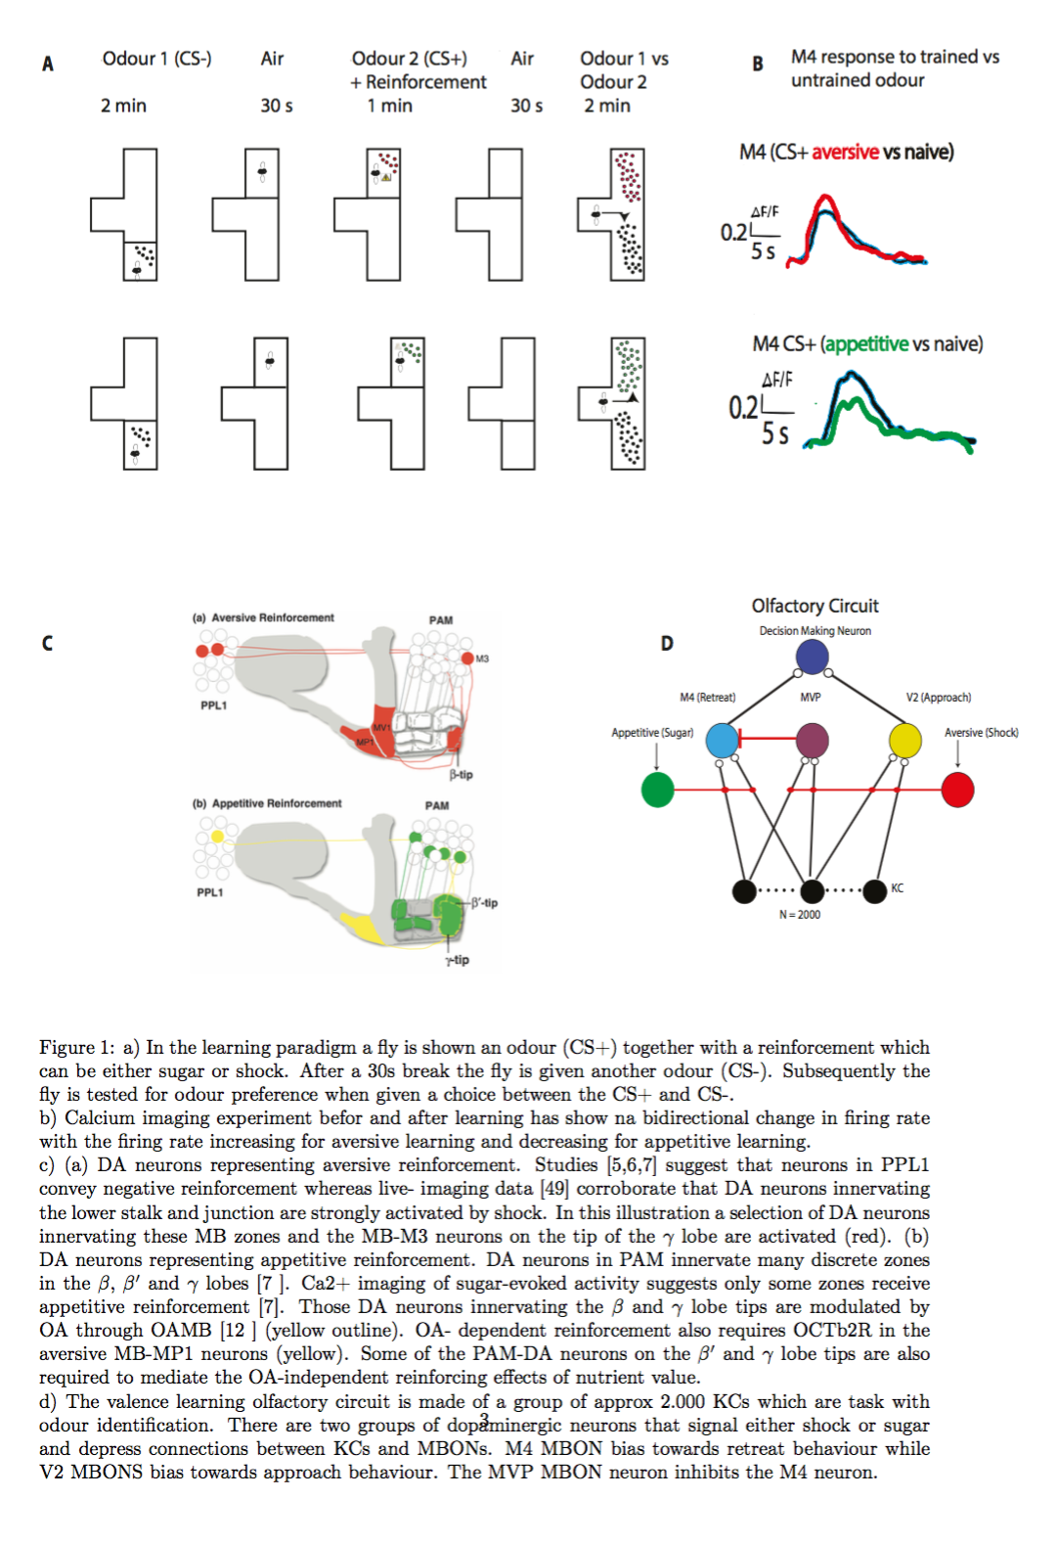

# METHODS

We describe the neuron models we usedin the computational simulations. We begin by describing the neuron model used in every simulation and we describe the parameters used in each simulation.

τ m dV dt =( V rest -V )+ g ex ( E ex -V )+ g inh ( E inh -V ) (1)

Here V is the membrane potential of the neuron as a function of time , τ m is the membrane time constant, V rest is the resting membrane potential, E ex is the excitatory reversal potential and E in is the inhibitory reversal potential. g ex and g inh are the synaptic conductances.

They are modelled according to the following equations

τ ex d g ex =- g ex (2)

τ inh d g inh dt =- g inh (3)

τ ex and τ inh are the synaptic time constants for the excitatory and the inhibitory conductance, respectively. When the neuron receives an action potential from a presynaptic cell the postsynaptic conductance increases by the following formulas: g ex → g ex + Δ g ex and g inh → g inh + Δ g inh .

To model the KC firing patterns we used experimental data (Turner, Bazhenov, & Laurent, 2008)

STDP equation:

S i (t)= ∑ k δ ( t- t i,k * ) (4)

d x j (t) d t =- x j (t) τ + + S j (t)f (5)

d y i (t) d t =- y i (t) τ - + S i (t) (6)

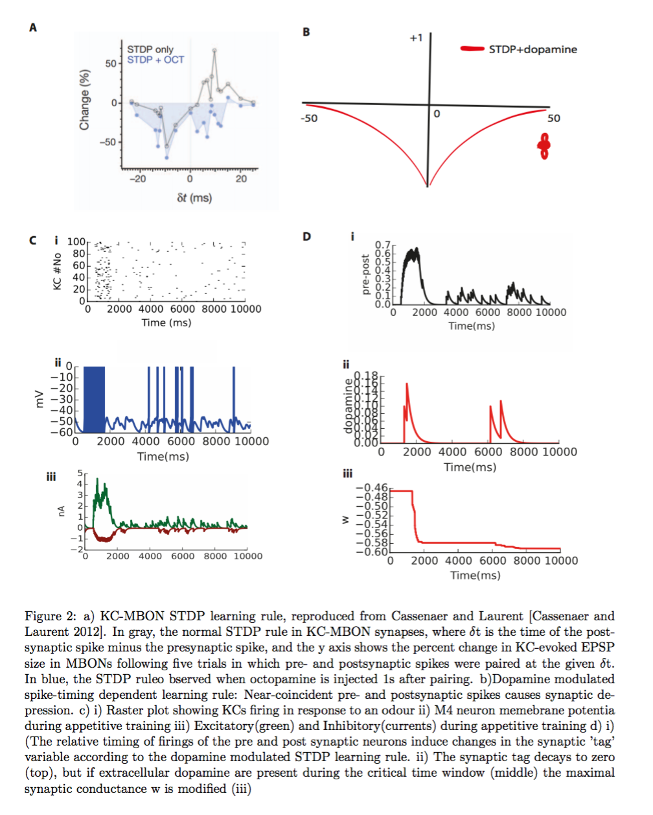

klklkl.

# RESULTS

Our results show that a dopamine modulated learning rule where dopamine shifts the learning rule into a regime where both pre before post and post before pre spike pairs lead to LTD is sufficient to explain

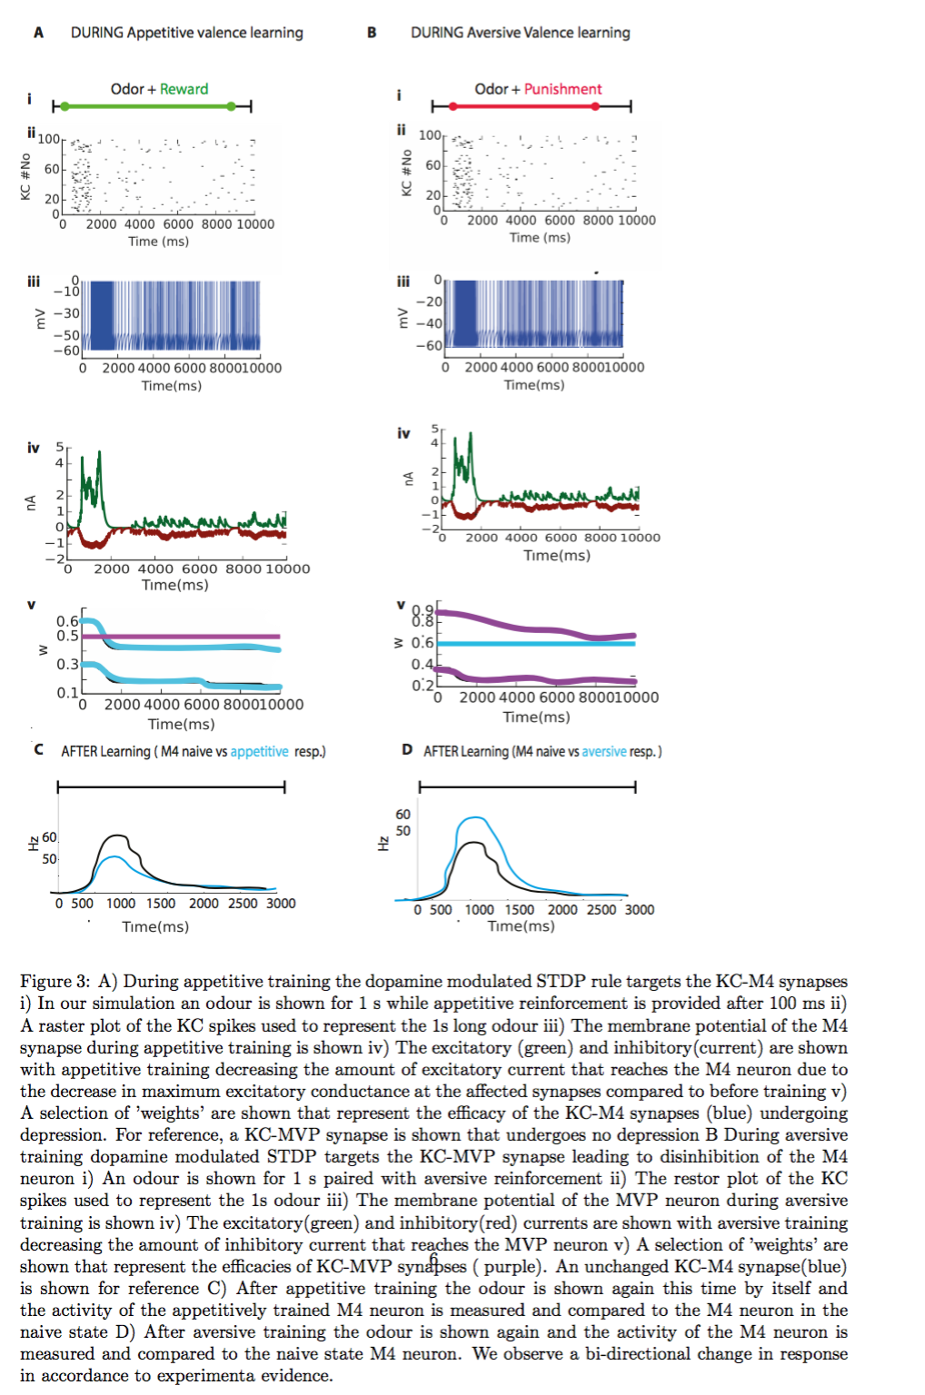

# FUTURE GOALS

# 

**I. Building a computational model of how the fly learns to associate odours with appetitive and aversive stimuli in the mushroom body through the interaction of plasticity and neuromodulation.**

Recent studies investigating the fruit-fly olfactory system have shown that sparse responses to odours can exhaustively describe the full spectrum of possible stimuli. It is still unclear how this representation can be enriched by additional information such as previously experienced rewards or punishments. The current hypothesis is that this information is stored in the synapses from the Kenyon Cells to the output neurons and that plasticity occurs at these synapses as a consequence of dopamine and octopamine release.

The release of the two neuromodulators is thought be a response to unexpected rewards or punishments, making it possible to store the association between reward and stimulus ((Waddell, 2013). It is currently unknown what plasticity mechanism signals change and how these neuromodulators act mechanistically on the system in synergy with plasticity. One hypothesis proposes that dopamine makes synapses malleable and octopamine dictates the direction of the change in response to pre and post spiking ((Waddell, 2013)). Alternatively, they may be acting as two distinct effectors on separate synapse populations. Yet another hypothesis indicates that octopamine gates the activity of a subpopulation of dopaminergic neurons.

The first two scenarios can be approximated using a so-called three-factor learning rule (Frémaux, Sprekeler, & Gerstner, 2010) , (2014), but these rules will likely fail to reproduce the experimental results my collaborators have obtained on

the activity of output neurons in response to appetitive or aversive stimuli (Owald et al., 2015), because they don’t take into consideration the interaction between different neuro-modulators. The experiment used by my collaborators to study how odours are discriminated is called the classical conditioning experiment. Traditionally, sugar is used as the reward, and electric shock for punishment in these types of experiments.

The flies can receive either a sugar reward or a shock (the un- conditioned stimulus, US), in association with one of the odours (the conditioned stimulus, CS+). They are then presented with a counter odour without electric shock or sugar (the CS-). After training, the animals are presented with a choice of one of the two converging odours presented to them in a T-maze, and their selective avoidance of the shock-associated odour or approach for sugar-associated odour is calculated into a performance index.

As a first step, I will build a toy model of the olfactory circuit to integrate these different hypotheses and generate testable predictions for future experiments and to rule out the theories that can be invalidated. I will build on previous firing rate models that describe the transformation of odours into Kenyan Cell representations and I will develop several different plasticity rules, one for each hypothesis.

For the first time, I will study several neuromodulators acting at the same time on the same system. This aim could have a large impact on understanding the role of different neuromodulators in mammals, since until now they have been studied in isolation, even though in vivo they certainly interact with each other ( (Harris, 1991) )

The data that our collaborators from the Waddell lab have gathered shows that the firing rate of a family of output neurons in the mushroom body will decrease after an odour associated with a negative stimulus is presented. Conversely, when an odour associated with a positive stimulus is presented, the firing rate increases.

To build a model that can capture these observations I will also need to extend previous work that has measured the initial responses of olfactory neurons to a set of odours (Hallem & Carlson, 2006) Previous work (Luo, Axel, & Abbott, 2010) has modelled the transformation that occurs in the antennae lobe in an abstract rate-based model. The transformation takes into account lateral inhibition coming from local interneurons in the antennal lobe.

This acts to decorrelate odour representations, which makes Kenyon Cell responses more selective to different odours. They show that sparseness in the mushroom body can be maintained with global inhibition a precise number of contacts between Projection Neurons and Kenyon Cells. This model has been used extensively to test hypotheses about other processes in the olfactory circuit (Parnas, Lin, Huetteroth, & Miesenböck, 2013).

We will use this model as a starting point to explore the learning of appetitive and aversive odour responses. We will add output neurons and neuromodulatory controls comprised of two families of neurons: octopamine and dopamine.

We will employ a realistic plasticity mechanism at the synapse between Kenyon cells and output neurons to account for how the fly learns aversive and appetitive behaviour. This involves depressing the synapse when a reward is presented and strengthening the synapse when a punishment is presented. This type of plasticity mechanism will combine Hebbian learning with neuromodulation.

Hebbian learning rule states that change in the strength of a connection depends on pre and postsynaptic neural activities (Hebb 1949). Many variants have been proposed, that I could employ to study how they would work in conjunction with neuromodulation.

One such variant that we will explore is the BCM rule where synaptic strength changes depending on the current input compared to the average output activity (Bienenstock, Cooper, & Munro, 1982)

Another rule that I will test is the covariance rule. In this Hebbian inspired weight change is proportional to the covariance of the firing rates Weight will increase if pre and post firings are positively correlated and decrease if they negatively correlated (Sutton and Barto (1998).

Neuromodulation will gate the change of strength of synapse in these models.

After I single out a plasticity mechanism that is in accordance to experimental results I will subsequently try a more difficult test for my model. I will choose two odours that have an overlapping representation in the Kenyon Cells and pair the first odour to a reward.

I will subsequently present the model with the second odour. This will be done to test whether the second odour can trigger a change in the firing rate of the output neuron, which my system was trained to exhibit when presented the first odour. If my model makes that predictions than my collaborators will be able to test that in an experiment.

**II. Converting a standard toy model of the olfactory circuit into a biologically plausible network**

In my previous aim, I propose to model how a number of different modulatory plasticity mechanisms can help store memories about the ‘value’ of a certain stimulus.

A weakness of the Luo et al. model we use in Aim 1 is that the network doesn’t capture the temporal dynamics that actual neurons have. The logical step towards efficacies and timescales found in the real fly brain.

This also involves ensuring that the network is “Dalian,” meaning that each neuron can only exhibit an excitatory or inhibitory effect on downstream targets, but not both.

Here, I will start by developing a recurrent spiking network model that converts the projection neuron odour responses predicted by Luo et al. into spike trains that drive the input of Kenyon Cells. 150 projection neurons drive the excitatory input to the mushroom body’s 2500 Kenyon cells. The Kenyon cells will be modelled using the LIF model, which features four flexible parameters that can be fit to particular cell types. This model was used in a previous network simulation of the Kenyon Cells.

Sparseness in the Mushroom Body has been shown to be maintained by negative feedback inhibition coming from a single neuron, called the anterior paired lateral (APL) neuron. The APL neuron receives its input from KCs, which creates the feedback (Lin, Bygrave, de Calignon, Lee, & Miesenböck, 2014).

In the Luo et al. model, inhibition is modelled conceptually as a negative offset on the weights between PNs and KCs. I will explicitly model this inhibition in my syste9m as a single inhibitory neuron that provides negative feedback inhibition to the Kenyon Cells.

 The feedback from the APL to KCs ensures that inhibition is proportional to the total amount of excitation in the mushroom body, giving rise to global balance of excitation and inhibition.

It is not known what plasticity mechanisms might give rise to the E-I balance observed in the mushroom body. Testing how sparse odour representation can be achieved through E-I balance in realistic neurons will be a valuable effort on its own because it will uncover potentially crucial simplifications Luo et al. have overlooked.

One obstacle in building a realistic model is tuning the strength of the synapses in a realistic way.

A candidate mechanism could be the inhibitory plasticity rule developed by (Vogels, Sprekeler, Zenke, Clopath, & Gerstner, 2011) which has been shown to stabilize the storage of memories when embedded in a recurrent network. This

rule relies on a symmetrical STDP rule that leads to long term potentiation (LTP) of inhibition when a feed forward interneuron fires within a short time difference of the postsynaptic cell, but long term depression (LTD) at larger intervals (Vogels et al., 2011)

The rule results in the formation of an inhibitory “anti-memory” that counteracts excitation to the network.

In modelling the mushroom body as a spiking network with realistic inhibitory input, I will push the understanding of the olfactory circuit closer to biological realism.

Most importantly, I will be able to verify the assumptions made in the rate network model of Luo et al. and to see whether or not the activity in the spiking implementation remains the same as the rate network predicts- this includes the sparse representations of Kenyon cells and the effects of global inhibition.

I will also be able to vary network parameters that may have an effect on overall odour coding or neuronal activity. Specifically, I will explore three parameters: inhibitory activity levels, the strength at each inhibitory synapse, and relative time scales of the excitatory and inhibitory input to the mushroom body.

In previous work, researchers have shown how the homeostatic plasticity can regulate a system after it has been disturbed (Lin et al., 2014)We will replicate these results using our newly developed model.

III. Bringing it all together. Plausible neuronal dynamics, E-I balance and neuromodulation in the olfactory circuit.

The previous two aims will pave the way towards building a realistic model of the olfactory circuit with respect to state of the art models. In the first aim I propose to study the role of multi-factor learning rules in mediating memory storage between KCs and output neurons.

In the second aim I convert Luo et al. firing rate model into an electrophysiologically realistic recurrent spiking models that can maintain a sparse code in a balanced network.

I will here readdress the first aim in the context of the recurrent spiking network that was used in Aim 2. This involves starting with the spiking network, and adding spiking neurons to represent the output neurons and dopamine neurons.

The most difficult part of this will be to reformulate the rate-based Hebbian learning rule developed in the first Aim into a plasticity rule that works at the level of spikes. The consequences of adding a temporal aspect to the learning are unclear, so it will be interesting to see how this affects the results.

Specifically, in the spiking network, the spiking activity of excitatory neurons will be quickly balanced through inhibition provided by the APL neuron.

This means that there is only a short temporal window during which downstream neurons can decode this information.

It is not clear if multifactor learning rules are able to decode this highly dynamic information.

I will test whether the rate-based learning rule developed in Aim 1 can still work under these constraints, and if not will develop a new learning mechanism.

It has been shown that spike-timing dependent plasticity (STDP) along with neuromodulation can tag synapses to be changed (Cassenaer & Laurent, 2007) .

I will try a similar mechanism here.

In summary, in this proposal I aim to explore how sparse odour information stored in a balanced spiking network can be read by the output neurons through a multifactor learning rule. By combining the first two aims into a more realistic model, I will further the understanding of fly olfactory learning to the level of the neural circuits involved and the dynamics that they exhibit. This will enable me to get a more unified understanding of reward-based learning in the fruit fly.

**3.2.6 Experimental validation**

Our predictions show that disinhibition of the inhibitory synapse between the MVP neuron unto the M4 neuron is sufficient to explain the increase in firing observed when imaging the M4 neuron after aversive learning. Further more, if the learning rule is ‘simple’ and dopamine always leads to depression of the KC-MBON synapse then we expect the feedback loop from the MBONs to DA to be excitatory. We predict that activating the

**Timeline**

# References

(2014). Solving the distal reward problem through linkage of STDP and dopamine signaling.

Aso, Y., Sitaraman, D., Ichinose, T., Kaun, K. R., Vogt, K., Belliart-Guérin, G., et al. (2014). Mushroom body output neurons encode valence and guide memory-based action selection in Drosophila. *eLife*, *3*, e04580. doi:10.7554/eLife.04580

Bienenstock, E. L., Cooper, L. N., & Munro, P. W. (1982). Theory for the development of neuron selectivity: orientation specificity and binocular interaction in visual cortex. *The Journal of Neuroscience : the Official Journal of the Society for Neuroscience*, *2*(1), 32–48.

Burke, C. J., Huetteroth, W., Owald, D., Perisse, E., Krashes, M. J., Das, G., et al. (2012). Layered reward signalling through octopamine and dopamine in Drosophila. *Nature*, *492*(7429), 433–437. doi:10.1038/nature11614

Cassenaer, S., & Laurent, G. (2007). Hebbian STDP in mushroom bodies facilitates the synchronous flow of olfactory information in locusts. *Nature*, *448*(7154), 709–713. doi:10.1038/nature05973

Frémaux, N., Sprekeler, H., & Gerstner, W. (2010). Functional requirements for reward-modulated spike-timing-dependent plasticity. *The Journal of Neuroscience : the Official Journal of the Society for Neuroscience*, *30*(40), 13326–13337. doi:10.1523/JNEUROSCI.6249-09.2010

Hallem, E. A., & Carlson, J. R. (2006). Coding of odors by a receptor repertoire. *Cell*, *125*(1), 143–160. doi:10.1016/j.cell.2006.01.050

Harris, R. M. (1991). Modulation of neural networks for behavior. *Annual Review of Neuroscience*.

Hige, T., Aso, Y., Rubin, G. M., & Turner, G. C. (2015). Plasticity-driven individualization of olfactory coding in mushroom body output neurons. *Nature*. doi:10.1038/nature15396

Honegger, K. S., Campbell, R. A. A., & Turner, G. C. (2011). Cellular-resolution population imaging reveals robust sparse coding in the Drosophila mushroom body. *The Journal of Neuroscience : the Official Journal of the Society for Neuroscience*, *31*(33), 11772–11785. doi:10.1523/JNEUROSCI.1099-11.2011

Lin, A. C., Bygrave, A. M., de Calignon, A., Lee, T., & Miesenböck, G. (2014). Sparse, decorrelated odor coding in the mushroom body enhances learned odor discrimination. *Nature Neuroscience*, *17*(4), 559–568. doi:10.1038/nn.3660

Luo, S. X., Axel, R., & Abbott, L. F. (2010). Generating sparse and selective third-order responses in the olfactory system of the fly. *Proceedings of the National Academy of Sciences*, *107*(23), 10713–10718. doi:10.1073/pnas.1005635107

Niewalda, T., Singhal, N., Fiala, A., Saumweber, T., Wegener, S., & Gerber, B. (2008). Salt processing in larval Drosophila: choice, feeding, and learning shift from appetitive to aversive in a concentration-dependent way. *Chemical Senses*, *33*(8), 685–692. doi:10.1093/chemse/bjn037

Owald, D., Felsenberg, J., Talbot, C. B., Das, G., Perisse, E., Huetteroth, W., & Waddell, S. (2015). Activity of Defined Mushroom Body Output Neurons Underlies Learned Olfactory Behavior in Drosophila. *Neuron*, *86*(2), 417–427. doi:10.1016/j.neuron.2015.03.025

Parnas, M., Lin, A. C., Huetteroth, W., & Miesenböck, G. (2013). Odor Discrimination in Drosophila: From Neural Population Codes to Behavior. *Neuron*, *79*(5), 932–944. doi:10.1016/j.neuron.2013.08.006

Perisse, E., Yin, Y., Lin, A. C., Lin, S., Huetteroth, W., & Waddell, S. (2013). Different Kenyon Cell Populations Drive Learned Approach and Avoidance in Drosophila. *Neuron*, *79*(5), 945–956. doi:10.1016/j.neuron.2013.07.045

Pitman, J. L., Huetteroth, W., Burke, C. J., Krashes, M. J., Lai, S.-L., Lee, T., & Waddell, S. (2011). A Pair of Inhibitory Neurons Are Required to Sustain Labile Memory in the Drosophila Mushroom Body. *Current Biology*, *21*(10), 855–861. doi:10.1016/j.cub.2011.03.069

Turner, G. C., Bazhenov, M., & Laurent, G. (2008). Olfactory Representations by Drosophila Mushroom Body Neurons. *Journal of Neurophysiology*, *99*(2), 734–746. doi:10.1152/jn.01283.2007

Vogels, T. P., Sprekeler, H., Zenke, F., Clopath, C., & Gerstner, W. (2011). Inhibitory plasticity balances excitation and inhibition in sensory pathways and memory networks. *Science*, *334*(6062), 1569–1573. doi:10.1126/science.1211095

Waddell, S. (2013). Reinforcement signalling in Drosophila; dopamine does it all after all. *Current Opinion in Neurobiology*, *23*(3), 324–329. doi:10.1016/j.conb.2013.01.005